Shepherd of the Valley Lutheran Church
Sunday, April 21 2024
Fourth Sunday of Easter
10:00 A.M. Worship with Holy Communion

Welcome visitors! We have a weekly email you can join to be notified about
upcoming events (aageorge27@sbcglobal.net), as well as a
website (www.sov-lc.org) and a Facebook presence.
Normal print indicates Pastor
L: indicates Lay Reader
Bold indicates congregational response

GATHERING
The Holy Spirit calls us together as the people of God

PRELUDE St. Columba setting by Hiram Titus
Shepherd Me, O God arranged by Mark Hayes

welcomE
Worship Announcements and Prayer concern sharing
Ringing of the church bell
confession and forgiveness
Blessed be the holy Trinity, ☩ one God, who creates, redeems, and sustains us
and all of creation. Amen.

Let us confess our sin in the presence of God and of one another.

To you, O God,
all hearts are open, to you all desires known. We come to you, confessing our sins. Forgive us in your mercy, and remember us in your love. Show us your ways; teach us your paths; and lead us in justice and truth, for the sake of your goodness in Jesus Christ our Savior. Amen.

By water and the Holy Spirit God gives you a new birth, and through the death and resurrection of ☩ Jesus Christ, God forgives you all your sins. The God of mercy and might strengthen you in all goodness and keep you in eternal life.

Amen.

GATHERING HYMN The King of Love My Shepherd Is ELW #502
GREETING
P: Christ is risen.
He is risen indeed.
P: Christ is risen.
He is risen indeed!
P: Christ is risen.
He is risen indeed! Alleluia!

KYRIE
CANTICLE OF PRAISE Glory be to God
PRAYER OF THE DAY
The Lord be with you. And also with you

Let us pray. O Lord Christ, good shepherd of the sheep, you seek the lost and guide us into your fold. Feed us, and we shall be satisfied; heal us, and we shall be whole. Make us one with you, for you live and reign with the Father and the Holy Spirit, one God, now and forever. Amen.

WORD
God speaks to us in scripture reading, preaching, and song

CHILDREN'S TIME

A Reading from Acts 4:5-12

⁵The next day [the] rulers, elders, and scribes assembled in Jerusalem, ⁶with Annas the high priest, Caiaphas, John, and Alexander, and all who were of the high-priestly family. ⁷When they had made the prisoners stand in their midst, they inquired, “By what power or by what name did you do this?” ⁸Then Peter, filled with the Holy Spirit, said to them, “Rulers of the people and elders, ⁹if we are questioned today because of a good deed done to someone who was sick and are asked how this man has been healed, ¹⁰let it be known to all of you, and to all the people of Israel, that this man is standing before you in good health by the name of Jesus Christ of Nazareth, whom you crucified, whom God raised from the dead. ¹¹This Jesus is
‘the stone that was rejected by you, the builders;
it has become the cornerstone.’
¹²There is salvation in no one else, for there is no other name under heaven given among mortals by which we must be saved.”
Word of God, Word of Life Thanks be to God.

Responsive Prayer: Psalm 23 sung

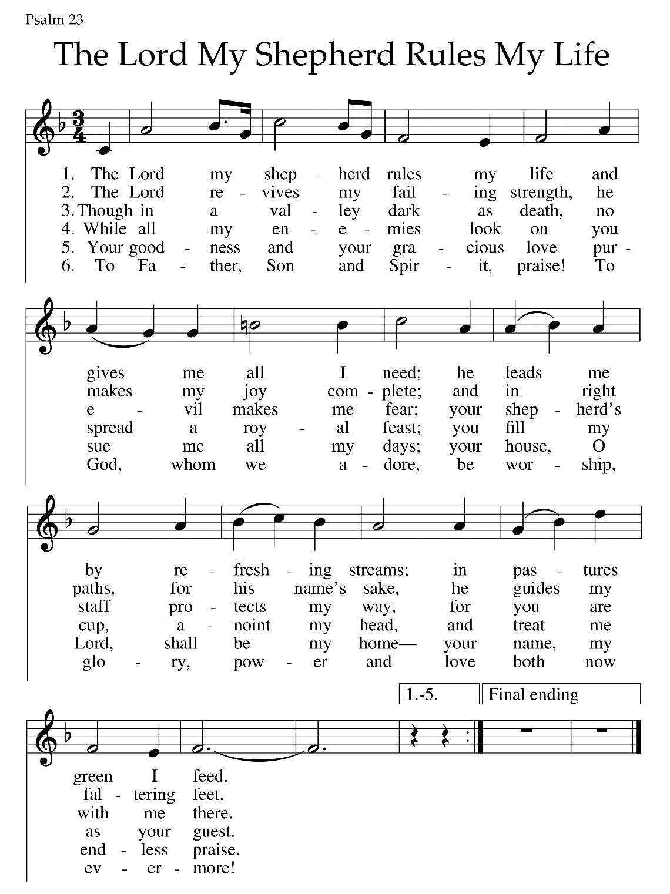

A Reading from 1 John 3:16-24

¹⁶We know love by this, that [Jesus Christ] laid down his life for us—and we ought to lay down our lives for one another. ¹⁷How does God’s love abide in anyone who has the world’s goods and sees a brother or sister in need and yet refuses help?
¹⁸Little children, let us love, not in word or speech, but in truth and action. ¹⁹And by this we will know that we are from the truth and will reassure our hearts before him ²⁰whenever our hearts condemn us; for God is greater than our hearts, and he knows everything. ²¹Beloved, if our hearts do not condemn us, we have boldness before God; ²²and we receive from him whatever we ask, because we obey his commandments and do what pleases him.
²³And this is his commandment, that we should believe in the name of his Son Jesus Christ and love one another, just as he has commanded us. ²⁴All who obey his commandments abide in him, and he abides in them. And by this we know that he abides in us, by the Spirit that he has given us.

Word of God, Word of Life Thanks be to God.

GOSPEL ACCLAMATION

GOSPEL: John 10:11-18

The holy gospel according to John Glory to you, O Lord.

[Jesus said:] ¹¹“I am the good shepherd. The good shepherd lays down his life for the sheep. ¹²The hired hand, who is not the shepherd and does not own the sheep, sees the wolf coming and leaves the sheep and runs away—and the wolf snatches them and scatters them. ¹³The hired hand runs away because a hired hand does not care for the sheep. ¹⁴I am the good shepherd. I know my own and my own know me, ¹⁵just as the Father knows me and I know the Father. And I lay down my life for the sheep. ¹⁶I have other sheep that do not belong to this fold. I must bring them also, and they will listen to my voice. So there will be one flock, one shepherd. ¹⁷For this reason the Father loves me, because I lay down my life in order to take it up again. ¹⁸No one takes it from me, but I lay it down of my own accord. I have power to lay it down, and I have power to take it up again. I have received this command from my Father.”

The gospel of the Lord. Praise to you, O Christ.

SERMON Pastor Andrew Heisen

HYMN OF THE DAY Shepherd Me, O God ELW #780

APOSTLES’ CREED

I believe in God, the Father almighty,
creator of heaven and earth.
I believe in Jesus Christ, God’s only Son, our Lord,
who was conceived by the Holy Spirit,
born of the virgin Mary,
suffered under Pontius Pilate,
was crucified, died, and was buried;
he descended to the dead.*
On the third day he rose again;
he ascended into heaven,
he is seated at the right hand of the Father,
and he will come to judge the living and the dead.
I believe in the Holy Spirit,
the holy catholic church,
the communion of saints,
the forgiveness of sins,
the resurrection of the body,
and the life everlasting. Amen.

PRAYERS OF INTERCESSION

Rejoicing that Jesus is risen and love has triumphed over fear, let us pray for the church, the world, and all those in need of good news.
A brief silence.
L: Shepherding God, gather your church whenever we wander from you and one another. Empower our church in ministries around the world to worship and serve alongside global companions as equal partners and coworkers in the gospel. God of grace, hear our prayer.
L: Nurturing God, preserve the health of biomes and ecosystems. Inspire scientists, researchers, conservation organizations, and all people entrusted with the task of caring for creation, that we may be better stewards of the world around us. God of grace, hear our prayer.
L: Almighty God, lead nations and communities to share resources, cooperate in solving conflicts, and listen to the wisdom of Indigenous peoples. Help all those with power to share it and to use such power for good. God of grace, hear our prayer.
L: Loving God, protect the very young and the very old, those living without housing, victims of domestic abuse, and all who live with chronic illness or compromised immune systems. Guide communities to actively care for people who are vulnerable. God of grace, hear our prayer.
L: Gracious God, help this and all communities of faith to listen for your voice. Call us away from things that distract us from following you. Invite us to more deeply love and serve people who are lonely, isolated, and on the margins. God of grace, hear our prayer.

Here other intercessions may be offered.

L: Living God, we give thanks for our ancestors in faith, including Anselm of Canterbury and all who labored to help generations understand the good news of the gospel. Strengthen us to share the good news in our own day. God of grace, hear our prayer.

Into your hands, most merciful God, we commend all for whom we pray, trusting in your abiding love; through Jesus Christ, our resurrected and living Lord. Amen.

SHARING OF THE PEACE
MEAL
God feeds us with the presence of Christ

offering prayer
L: Let us pray. Living God, you gather the wolf and the lamb to feed together in your peaceable reign, and you welcome us all at your table. Reach out to us through this meal, and show us your wounded and risen body, that we may be nourished and believe in Jesus Christ, our Savior and Lord. Amen

THe Great thanksgiving
The Lord be with you.
And also with you.
Lift up your hearts.
We lift them to the Lord.
Let us give thanks to the Lord our God.
It is right to give our thanks and praise…
…. unending hymn:

HOly, HOly, HOly
Eucharistic prayer with words of institution

…Proclaim the mystery of faith:
Christ has died, Christ is risen, Christ will come again.

*LORD'S PRAYEr (Whichever form or language you prefer)
Our Father in heaven,  hallowed be your name,  your kingdom come,  your will be done,  on earth as in heaven.  Give us today our daily bread.  Forgive us our sins  as we forgive those  who sin against us.  Save us from the time of trial  and deliver us from evil.  For the kingdom, the power,  and the glory are yours,  now and forever. Amen. | Our Father, who art in heaven,  hallowed be thy name,  thy kingdom come,  thy will be done,  on earth as it is in heaven.  Give us this day our daily bread;  and forgive us our trespasses,  as we forgive those  who trespass against us;  and lead us not into temptation,  but deliver us from evil.  For thine is the kingdom,  and the power, and the glory,  forever and ever. Amen.

invitation to communion
Lamb of GOd
POST-COMMUNION BLESSING
post-communion Canticle
Post-Communion Prayer
L: Let us pray. We give you thanks, generous God, for in this bread and cup we have tasted the new heaven and earth where hunger and thrist are no more. Send us from this table as witnesses to the resurrection, that through our lives, all may know life in Jesus’ name. Amen.

SENDING
God blesses us and sends us in mission to the world

BLESSING

sending hymn Touch that Soothes and Heals
ANNOUNCEMENTS & DISMISSAL
Go in peace and serve the Lord. Thanks be to God.

POSTLUDE Resignation setting by Jerry van der Pol

From sundaysandseasons.com. Copyright © 2024 Augsburg Fortress
All rights reserved. Reprinted by permission under Augsburg Fortress Liturgies Annual License SAS011356

